HUNGER KNOWS NO SEASON!

There are many ways to run a school or church Food Drive. Often schools will offer free admittance to a school sporting or cultural event or teachers may offer extra credit to anyone who contributes a non-perishable food item. Schools and churches can also create some excitement by choosing a “theme” over a designated period of time. Listed below are a few creative themes to encourage the items most needed by the food pantry. FISH of McHenry thanks you for your support!

To eliminate breakage, plastic or canned items are requested.
PLEASE CHECK ALL EXPIRATION DATES BEFORE DONATING FOOD!

SEASONAL FOOD DRIVE THEMES

“Back to School” or “Little Bites for Tikes Food Drive”*** (September or any time of year): favorite lunch box items & kid-friendly foods such as peanut butter, jelly (plastic bottles), granola bars, soup, mac & cheese, canned pastas, jello, pudding, canned fruit, individual packs of applesauce, raisins, fruit snacks, snack crackers or cookies, canned or plastic bottled juices
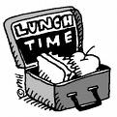

***This type of Food Drive is also a fun option for Religious Ed. Classes, Daycare Centers, After School Programs, Youth Groups, Vacation Bible School, or a Class Project for kids to bring their own favorites
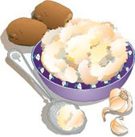

“Giving Thanks” or Holiday Food Drives (Thanksgiving, Christmas & Easter): canned hams, favorite side dishes plus extras such as stuffing mix, gravy, instant mashed potatoes, canned sweet potatoes or yams, marshmallows, green bean casserole items, olives, pickles, vegetables, cranberries, pie crusts, pumpkin and fruit pie filling, coffee, tea, hot chocolate
“Holiday Baking” Food Drive: flour, sugar (white, brown or powdered), chocolate chips, brownie, bread, gingerbread, cookie, cake & muffin mixes, canned or boxed frosting mixes, pie crusts, pie filling, nuts, cooking oil & shortening, shredded coconut, cocoa, decorative toppings
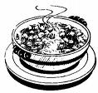

Winter Warm Up” Food Drive or “Souper Bowl” Food Drive: (from November - February or near Super Bowl Sunday): dry or canned soup, crackers, canned stews, canned meats & chili, pork & beans, pasta, rice, hot chocolate, any hot beverages (coffee, tea, cider), oatmeal, cream of wheat, canned or instant potatoes, gravy, hamburger helper, mac & cheese

FOOD DRIVES FOR ANY SEASON

“Rise & Shine” Food Drive: breakfast items such as pancake or baking mix, pancake syrup, oatmeal (reg. & instant), boxed cereal, muffin & coffee cake mixes, bisquick or biscuit mix, nut & sweet bread mixes, canned fruit, jelly, jam, honey, coffee, tea, canned or plastic bottled juices
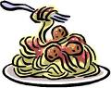
“A Taste of Italy” or “Multicultural Food Drive”: all kinds of pasta, spaghetti sauce, tomato products, pizza sauce, pizza dough mix, parmesan cheese, olives (black & green), olive oil, rice, beans (black, pinto, refried, garbanzo), salsa, taco seasonings, Mexican & hot sauces
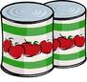
“Canned Meat” or “We CAN-DO It!” Food Drive: all canned-food such as chicken, chili, ham, hash, spam, tuna, all types of vegetables, tomato products, soups, sauces, fruit, meat and pasta, beans (black, pinto, refried, baked, kidney, garbanzo)
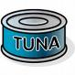

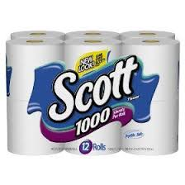
“Paper Products” or “Personal Care” Food Drive: toilet paper, paper towels & napkins, facial tissue, aluminum foil, plastic wrap, dish soap, household cleaners, shampoo/conditioner, toothpaste, bar soap, deodorant, laundry soap, feminine hygiene products, baby wipes, diapers

FISH of McHenry 815-344-4717 Pantry Location: 3515 N. Richmond Rd. McHenry, IL

Pantry Hours: Tuesdays & Thursdays 9:00am -11:30am
3rd Tuesday of each month: 4:30pm – 6:30pm

